**Moovalur Ramamirtham Ammaiyar Ninaivu Marriage Assistance Scheme**:

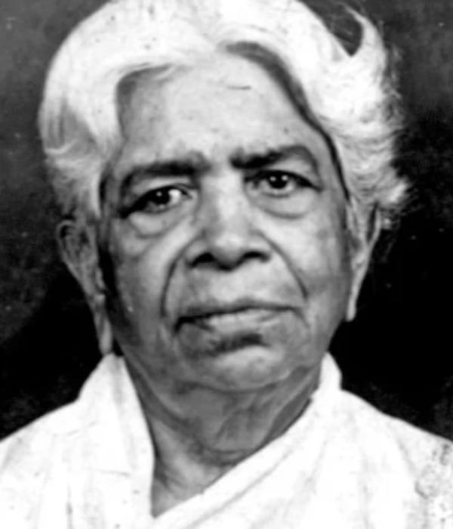

**Details:**

"Moovalur Ramamirtham Ammaiyar Ninaivu Marriage Assistance Scheme-1" is a flagship scheme announced by the Hon’ble Chief Minister of Tamil Nadu. The scheme is implemented by the Social Welfare Department, Govt. of Tamil Nadu. Under the scheme, Cash Assistance of ₹ 25,000/- and an 8-gram gold coin is given to brides who have studied Class 10th. This scheme is only applicable for the marriage conducted from 17th May 2011 onwards. The objective of the scheme is to help financially poor parents in getting their daughters married. In most communities, it is a customary cultural requirement for a girl to wear “Thirumangalyam” made of gold during marriage and the parents celebrate the marriage function according to their customs and cultural backgrounds. "Moovalur Ramamirtham Ammaiyar Ninaivu Marriage Assistance Scheme-1" is one of the Five Marriage Assistance Schemes introduced by the Govt. of Tamil Nadu to help such parents and to encourage them to educate their daughters till the right age.

**Benefits:**

1.Cash assistance of ₹ 25,000 (paid through the Electronic Clearing Service ECS).

2.One Sovereign (8 gram) 22-carat Gold Coin.

NOTE: In case of death of parents, assistance is given to the daughter.

**Eligibility:**

1. The annual income of the family of the applicant should not exceed ₹ 72,000/-.

2. The girl should be of the legal marriage age, i.e. 18 years or above.

3. The boy should be of the legal marriage age, i.e. 21 years or above.

4. The girl should have studied upto 10th Standard. As a special case, a bride from the Scheduled Tribe community, with a minimum education of 5th Standard, can also avail of this scheme.

5. Only one girl from a family is eligible.

**DOCUMENT REQUIRED:**

* Income Certificate.
* Community Certificate.
* Marriage Invitation.
* Copy of School Certificate.
* Copy of Marksheet of Class 10th.
* Ration Card.
* Transfer Certificate (or) Age Certificate for Bridegroom.
* Passport Sized Photo of the mother of the Bride, Bridegroom, and their Mother & Father.
* Bank Pass Book.
* Aadhar Card of the Bride’s Mother and Father.